

**MASENO UNIVERSITY**

**SCHOOL OF COMPUTING AND INFORMATICS**

**DEPARTMENT OF INFORMATION TECHNOLOGY**

**UNIT CODE: CIM 327 GROUP ICTM PROJECT PROPOSAL WRITING**

**TITTLE OF THE PROJECT: STUDENT ATTENDANCE SYSTEM**

**SUBMITED BY**

**JAPHETH RALPH NYADWERA**

**CIM/00094/022**

**AND**

**ALVIN NJOROGE**

**CIM/00086/021**

**UNDER THE GUIDANCE OF: MR. MOSES WAINAINA**

**SUBMITTED ON: 4TH JANUARY 2025**

# DECLARATION

We declare that this work is our own work except as cited in the references. The report has not been accepted for any degree and is not being submitted concurrently in candidature for any degree or other award.

Name of candidate: JAPHETH RALPH NYADWERA

Signature: ……………………….

Date: ……………………….

Name of candidate: ALVIN NJOROGE

Signature: ……………………….

Date: ……………………….

# DEDICATION

This project is dedicated to Almighty GOD for the knowledge, understanding wisdom and inspiration throughout the project. May his name live forever!

We would like also to dedicate this project to our parents who have been giving words of encouragement throughout the study. We are forever grateful.

# 

# ACKNOWLEDGEMENT

We are highly appreciative to the Almighty God for all His wisdom and grace that has seen us through the writing of this project.

we would like to express our deep gratitude to Mr. Moses Wainaina, our project supervisor for his valuable and constructive suggestions during the project. His willingness to give his time generously has been much appreciated.

# 

# ABSTRACT

Uniqueness or individuality of an individual is his/her fingerprints. So, this project of fingerprints of an individual which is used for the purpose of attendance marking automatically. Attendance for students is very important for every College, Universities, and schools. Conventional methodology for taking attendance is by calling the name or roll number of the student and the attendance is recorded. Time consumption for this purpose is an important point of concern. Assume that the duration for one subject is around 60 minutes or 1 hour & to record attendance takes 5 to 10 minutes. For every tutor this is consumption of time. To stay away from these losses, an automatic process will be used in this project which is based on fingerprints processing. In this project fingerprint detection and fingerprint recognition is used. The database of all the students in the class is stored and when the fingerprints of the individual student matches with one of the fingerprints stored in the database then the attendance is recorded.

Table of Contents

DECLARATION 2

DEDICATION 3

ACKNOWLEDGEMENT 3

ABSTRACT 4

CHAPTER 1 6

1.0 INTRODUCTION 6

1.1 BACKGROUND STUDY 7

1.2 PROBLEM STATEMENT 7

1.3 OBJECTIVES OF THE STUDY 7

1.3.1 General: 7

1.3.2 Specific objectives: 7

1.4 RESERCH QUESTIONS 8

1.5 SCOPE OF THE STUDY 8

1.6 SIGNIFICANCE OF THE STUDY 8

1.7 LIMITATIONS OF THE STUDY 8

1.8 ASSUMPTIONS OF THE STUDY 9

1. Student Compliance 9

2. Functionality of Biometric Devices 9

3. Data Security 9

4. Technical Infrastructure 10

7. User Training 10

8. System Integration 10

9. Data Accuracy 10

10. Acceptance by Stakeholders 10

CHAPTER 2 11

2.0 LITERATURE REVIEW 11

2.1 Introduction 11

2.2 Related Work 11

2.2.1 Fingerprint-Based Attendance Systems 11

2.2.2 Comparison of Biometric vs. Non-Biometric Attendance Systems 11

2.2.3 Integration of Biometric Systems with Cloud 11

2.RELATED STUDIES 12

SUMMARRY OF THE RELATED WORKS 15

2.4 The General Gap 16

Hardware Limitations and Cost 16

Fingerprint Recognition Challenges 16

3.5 CONCLUSION 17

CHAPTER 3 18

Chapter 3: Methodology 18

3.1 Introduction 18

3.2 Research Design 18

Mixed-Method Research Design 18

Data Collection and Analysis 18

Integration of Findings 19

3.3 Target Population 19

3.4 Sample size and Justification 19

Justification 19

Sample Technique 21

3.5 Data collection methods 21

1. Surveys and Questionnaires 21

2. Interviews 21

3. Focus Groups 22

4. Observations 22

5. Document Analysis 23

6. User Feedback Forms 23

3.6 Data Sources and how they Align with objectives 24

3.7 Data Collection Instruments 25

3.8 Data Collection Procedure 25

3.9 Data Analysis Methods 26

3.9.1 Quantitative Data Analysis 26

3.9.2 Qualitative Data Analysis 26

Mixed Methods 27

Document Analysis 27

Continuous Feedback Analysis 28

4.0 System Design 28

4.0.1 System Development Methodology 28

System Development Life Cycle (SDLC) 28

Reasons for Choosing SDLC: 29

Agile Methodology 29

5.0 Design Tools 30

5.0.1 Context Diagram 30

5.0.2 Use Case Diagram 31

5.0.3 Activity Diagram 32

5.0.4 Entity relationship diagram 33

5.1 SYSTEM REQUIREMENTS 34

5.1.1 Hardware Requirements 34

5.1.2 Software Requirements 34

5.2 Validation and Testing 36

5.2.1 Validation Methods 36

5.2.2 Testing Methods 36

5.2.3 Criteria for evaluating the systems performance and usability 36

Performance Criteria 36

Usability Criteria 37

5.3 Ethical considerations 38

5.3.1 Privacy and Data Protection 38

5.3.2 User Rights and Autonomy 38

5.3.3 Bias and Fairness 38

5.3.4 Ethical Use and Oversight 38

5.4 REFERENCES 39

5.4.1 APPENDIX 1; 39

Estimated Budget Breakdown 39

Total Estimated Budget in 39

5.4.2 APPENDIX 2; 39

GANTT CHART 39

5.4.3 Information or article from a website with authors: 40

# 

# **CHAPTER** 1

## 1.0 INTRODUCTION

According to Wachira, Salome N (2018), class non-attendance has been frequenting in most institutions and has become a concern since a negative relationship exists between attendance and the overall performance, Current methods used to manage class attendance which are mostly use of sign sheets have been abused by students signing for their counterparts. Further, they are known to be misplaced and represented later and therefore not presenting the actual status. Data analyses using the current method is cumbersome due to their manual nature and linking with timetable and classroom is also a big issue. Drawing insights from Sogbodjor, P. (2021) as well, who conducted a case study on the Data Link Institute, this project seeks to leverage biometric technology to address common challenges associated with manual attendance recording. This study proposes use of fingerprint biometric identification for class attendance devoid of any kind of interference with the normal teaching procedure. Shoewu, O., Olaniyi, O. M., & Lawson, A. (2011) also highlights the benefits of an embedded computer-based lecture attendance management system in their study published in the African Journal of Computing & ICT. Moreover, Ivanilson, F. et al. (2012) discuss the development of an automatic attendance register system for the Cape Peninsula University of Technology (CPUT), emphasizing the practical applications of such systems in educational institutions. By automating the attendance process, the system will not only reduce administrative workload but also provide real-time data for better academic management and decision-making.

The system will be also implemented during exam sessions or in other teaching activities where attendance is highly essential. This system is to eliminate classical student identification such as calling name of the student, or checking respective identification cards of the student, which can not only interfere with the ongoing teaching process, but also can be stressful for students during examination sessions.

## 1.1 BACKGROUND STUDY

Countrywide, a number of students are pursuing university education. The need to raise their status in society, need for belonging, security at their work places, masterly of their teaching subjects and self-actualization among others, motivate students to enroll for university education. In Kenya for instance, the Kenyan Federal Government policies on education encourage access to university education by all citizen. As a result, many students including school leavers have access to learning centers in Kenyan universities. This project would improve the academic level of the nation as it will enhance class attendance of the student’s hence a learned nation.

## 1.2 PROBLEM STATEMENT

The traditional manual methods of monitoring student attendance in lectures are tedious as the signed attendance sheets have to be manually logged in to a computer system for analysis. This is tedious, time consuming and prone to inaccuracies as some students in the department often sign for their absent colleagues, rendering this method ineffective in tracking the students’ class attendance. Use of the fingerprint system in lieu of the traditional methods will provide a fast and effective method of capturing student attendance accurately while offering a secure, stable and robust storage of the system records, where upon authorization; one can access them for purposes like administration, parents or even the students themselves.

## 1.3 OBJECTIVES OF THE STUDY

### 1.3.1 General:

The main objective of the study is to design and develop a system for class attendance that uses biometrics for identification.

### 1.3.2 Specific objectives:

1. To identify and analyse existing biometric related systems.
2. To design a biometric based system that manages student class attendance.
3. To develop a biometric system of authentication during class attendance.
4. To test the developed system and understand its challenges.

## 1.4 RESERCH QUESTIONS

The research will try to answer the following questions;

1. What is the analysis on existing methods of identifying student attendance and what are their challenges?
2. What design method is effective to ensure challenges in the existing methods are countered?
3. Can the system be developed and tested in a classroom environment to ensure set minimum attendance is achieved and is there any challenge in its implementation?

## 1.5 SCOPE OF THE STUDY

We will be designing a system comprising of three modules:

1. Enrolment module. Will be to enrol users and their fingerprints into the system database.
2. Authentication module. Will be to validate the identity of the person who intend to access the system.
3. System database. Will consist of tables that stores records, each of which corresponds to an authorized that has an access to the system.

## 1.6 SIGNIFICANCE OF THE STUDY

There will be a lot of merits concerning the studies:

1. Students will be more regular in attending their classes since now no signature is required so no friend can mark attendance sheet on behalf of others as fingerprints are unique for every student.
2. Lecturers will not need to waste their time i.e., 15mins for taking attendance of students.
3. There will be no need to maintain attendance sheet as the attendance are stored electronically in database.
4. User will easily get attendance history of a particular student.
5. Saves time, cost, efforts and institution’s resources.

## 1.7 LIMITATIONS OF THE STUDY

1. Recognition Issues: Biometric systems can struggle with recognizing damaged or dirty fingerprints, which can be problematic if students have cuts, dirt, or grease on their fingers.
2. High Deployment Costs**:** Implementing biometric systems can be expensive due to the need for specialized hardware and software.
3. Privacy Concerns: Collecting and storing biometric data raises privacy issues, as this sensitive information could be vulnerable to theft or misuse.
4. Accuracy: While generally accurate, biometric systems can still have errors, especially with facial recognition systems being more accurate than fingerprint systems.
5. Environmental Challenges**:** Biometric systems can be less effective in environments with dirt, dust, or extreme conditions, such as construction sites or outdoor areas.
6. Remote and Field Workers**:** Biometric systems are not ideal for students or employees who work remotely or in the field, as they require physical presence for scanning.
7. Maintenance and Upgrades: Biometric systems require regular maintenance and updates to ensure they function correctly, which can be time-consuming and costly.

## 1.8 ASSUMPTIONS OF THE STUDY

### 1. Student Compliance

Assumption: All students will comply with the biometric system and regularly use it for attendance recording.

Rationale: For the system to be effective, it requires consistent use by all students.

### 2. Functionality of Biometric Devices

Assumption: Biometric devices (e.g., fingerprint scanners) are functioning correctly and are capable of accurately capturing and verifying biometric data.

Rationale: The accuracy and reliability of the attendance data depend on the proper functioning of these devices.

### 3. Data Security

Assumption: The biometric data collected is stored securely and is protected from unauthorized access or breaches.

Rationale: Ensuring data security is crucial to maintain the privacy and integrity of sensitive biometric information.

### 4. Technical Infrastructure

Assumption: The school has the necessary technical infrastructure (e.g., stable internet connection, network configuration) to support the biometric attendance system.

Rationale: A reliable technical infrastructure is essential for the real-time processing and storage of biometric data.

### 7. User Training

Assumption: All users, including students and teachers, have received adequate training on how to use the biometric system.

Rationale: Proper training ensures that users understand how to operate the system correctly, which minimizes errors and improves overall efficiency.

### 8. System Integration

Assumption: The biometric attendance system is fully integrated with existing class management systems (e.g., Student Information Systems) for seamless data transfer and reporting.

Rationale: Integration with existing systems is necessary for the effective management and utilization of attendance data.

### 9. Data Accuracy

Assumption: The biometric data captured is accurate and reflects the true attendance of students.

Rationale: The effectiveness of the attendance system is based on the accuracy of the data collected.

### 10. Acceptance by Stakeholders

Assumption: All stakeholders, including students and teachers accept and support the use of the biometric attendance system.

Rationale: Acceptance by stakeholders is crucial for the successful implementation and sustained use of the system.

# CHAPTER 2

## 2.0 LITERATURE REVIEW

## 2.1 Introduction

A literature review can be referred to as a review of current system that the researcher had done previously and the review of the system that will be developed. Literature review also focuses on the knowledge and ideas established on a topic as well as their strengths and weaknesses. Nowadays, technology is getting better and better to replacing the traditional system to speed up the process by introducing the computerized system. There are few types of attendance system that had been introduced nowadays in school, college, and university

## 2.2 Related Work

Several studies and research projects have been conducted to improve student attendance monitoring systems, particularly through biometric technologies. This section reviews previous work that has contributed to the development of biometric fingerprint attendance systems.

### 2.2.1 Fingerprint-Based Attendance Systems

A study by Kumar & Singh (2020) explored the implementation of a biometric fingerprint attendance system in universities. The research highlighted that fingerprint recognition improves accuracy, reduces proxy attendance, and enhances efficiency compared to manual attendance methods.

### 2.2.2 Comparison of Biometric vs. Non-Biometric Attendance Systems

A comparative analysis by Ahmed et al. (2021) examined RFID, facial recognition, and fingerprint-based systems. Their findings indicated that fingerprint-based systems were the most secure and accurate but required careful data encryption to prevent security breaches.

Chowdhury et al. (2020) analyzed face recognition and fingerprint attendance systems, concluding that fingerprint technology was more cost-effective and accurate in controlled environments but less effective for individuals with damaged fingerprints.

### 2.2.3 Integration of Biometric Systems with Cloud

Patel & Sharma (2022) explored integrating biometric attendance systems with cloud computing, allowing real-time monitoring and storage of attendance records. Their system enabled instant access to attendance data for teachers and administrators.

## 2.RELATED STUDIES

1. **RFID-based student attendance system and GSM-GPRS based student attendance system**. The GSM-GPRS based systems works by using the position of classroom for marking attendance which is not dynamic. Wrong attendance might be marked if schedule or location of the class changes. One of the problems with RFID based systems is that students will be compelled to always carry RFID cards and also the RFID detectors are needed to be installed.

**Benefits:**

Reduced Paperwork: By eliminating the need for paper-based attendance records, RFID systems help reduce clutter and improve organization

Accuracy and Reliability: RFID tags provide accurate and reliable attendance records, minimizing errors associated with manual systems

Enhanced Security: RFID tags are difficult to duplicate or forge, enhancing the security of attendance records.

Remote Monitoring: GSM-GPRS systems allow for attendance monitoring from remote locations, providing flexibility for administrators

Cost-Effective: Over time, the reduction in manual labor and the efficiency of the system can lead to cost savings for educational institutions

**Challenges:**

Cost of Implementation: Initial setup costs for RFID systems can be high, including the cost of RFID readers, tags, and necessary infrastructure

Maintenance: RFID systems require regular maintenance to ensure tags and readers are functioning correctly, which can add to the overall costs.

Network Dependency: GSM-GPRS systems rely heavily on cellular networks, which can be unreliable or have limited coverage in certain areas.

Data Costs: The transmission of data via GSM-GPRS can incur additional costs, especially if data usage is high.

Power Consumption: Devices used in GSM-GPRS systems can consume significant power, requiring regular charging or battery replacement

1. **Automated Teller Machine**(ATM).A system authentication using fingerprint Biometrics in the banking sector is a related study to this Personal Authentication System using fingerprint biometrics of students in institutions, where the students biometrics data are been collected in their various class, laboratory, examination halls and even tutorial by their lecturer, invigilators and even securities personnel in the institution to keep track of each student’s attendance performance in various courses.

**Benefits:**

Security. Secure Transactions: ATMs use secure PIN authentication, encryption, and other security measures to protect customer accounts and transactions.

. Cost-Effective. Reduced Staffing Costs: By automating routine transactions, ATMs help banks reduce the need for teller staff, leading to cost savings.

Time-Saving. Quick Transactions: ATMs allow for quick cash withdrawals, deposits, and balance inquiries, reducing the need to wait in long lines at bank branches.

**Challenges:**

. Technical Issues. Machine Malfunctions: ATMs can experience technical problems, such as jams or software failures, leading to inconvenience for users.

Security Risks. Fraud and Theft: ATMs can be targets for fraud, such as card skimming, where criminals steal card information using hidden devices.

Privacy Concerns. Lack of Privacy: Conducting transactions at an ATM can lack privacy, especially if the machine is located in a busy area.

1. **Biometric Voting Machine** where voters are being registered and vote using the fingerprint biometric. This machine makes the registration and voting efficient, fast and accurate in order to avoid cheating or imposter voting more than once. The objective of voting is to allow voters to exercise their right to express their choices regarding specific issues, pieces of legislation, citizen initiatives, constitutional amendments, recalls and to choose their government and political representatives.

**Benefits:**

Enhanced Accuracy and Security. Unique Identification: Biometric voting machines use unique physical characteristics (e.g., fingerprints, facial recognition) to identify voters, ensuring that each person can vote only once.

Reduced Human Error. Automated Processes: By automating the voting process, biometric systems minimize the potential for human error in voter identification and vote counting.

Cost Savings. Lower Operational Costs: Over time, biometric voting systems can reduce operational costs by minimizing the need for manual labour and reducing the potential for errors that require correction.

**Challenges:**

**High** Initial Costs. The cost of purchasing and setting up biometric voting machines can be substantial, including the costs of hardware, software, and system integration.

**Privacy** Concerns**.** Collecting and storing biometric data (e.g., fingerprints, iris scans) raises significant privacy issues and concerns about data protection and potential misuse.

**Technical** Issues. Biometric devices can malfunction or fail to recognize users accurately, which can cause delays and frustration during the voting process.

* 1. **Embedded Computer based Lecture Attendance Management system**. In this type of system, a card reader is interfaced with a digital computer system and an electronic card is provided and personalizes to each user for authentication. Authors like Shoewu, O., Olaniyi, O. M., & Lawson, A, used a wireless attendance management system that authenticates using the iris of the individual. The system uses an off-line iris recognition management system that can finish all the process including capturing the image of iris recognition, extracting minutiae, storing and matching.

**Benefits:**

**High Accuracy**: Iris recognition is one of the most reliable biometric methods, providing high accuracy in identifying individuals.

**Security**: Iris patterns are unique to each individual and remain stable over time, ensuring secure and reliable authentication.

**Speed**: Wireless systems allow for fast data transmission and processing, reducing the time needed to take and record attendance.

**Minimal** Maintenance: Once set up, these systems require minimal maintenance compared to manual attendance systems.

**Cost**-Effective: Over time, the reduction in manual labor and the efficiency of the system can lead to cost savings for educational institutions.

**Challenges:**

**High Initial Cost**: The setup cost for iris recognition systems is high, including the cost of specialized cameras and software.

**Complex Installation and Setup**: The installation and configuration process for iris recognition systems can be complex and time-consuming, requiring skilled personnel.

**Privacy Concerns:** Collecting and storing biometric data, particularly iris scans, raises significant privacy issues and concerns about data security.

**SUMMARRY OF THE RELATED WORKS**

|  |  |  |
| --- | --- | --- |
| Name of the related system | Benefits | Gap |
| Embedded Computer based Lecture Attendance Management system | Minimal **Maintenance**  Cost**-Effective**  Security is high  High Speed | High Initial Cost  Complex Installation and Setup  Privacy Concern |
| Biometric Voting Machine | . **Enhanced Accuracy and Security**  . **Reduced Human Error**. **Automated Processes**  **Cost Savings**. **Lower Operational Costs** | High **Initial Costs**  Privacy **Concerns**  Technical **Issues** |
| Automated Teller Machine (ATM) | . **Cost-Effective**  **Time-Saving**  **Secure Transactions** | **Technical Issues**  . **Security Risks**  **Lack of Privacy** |
| RFID-based student attendance system and GSM-GPRS based student attendance system | **Reduced Paperwork**  **Accuracy and Reliability**  **Enhanced Security**  **Remote Monitoring**  **Cost-Effective** | . **Cost of Implementation**  **High Maintenance**  **Network Dependency**  **Power Consumption**  **High Data Costs** |

## 

## 2.4 The General Gap

From the reviewed literature and related systems, it is evident that while biometric fingerprint-based attendance systems offer greater accuracy, security, and efficiency than traditional methods, there are still notable gaps that need to be addressed. These gaps include:

### Hardware Limitations and Cost

Most fingerprint-based attendance systems require specialized fingerprint sensors and database servers, which can be costly to implement in large institutions.

Maintenance and repair of biometric hardware also add to the long-term operational costs.

### Fingerprint Recognition Challenges

Some students may experience fingerprint recognition failures due to scars, dirt, moisture, or worn-out fingerprints, reducing the system’s effectiveness.

In cases of poor-quality fingerprint scans, multiple attempts are required, leading to delays in attendance marking.

1. **Security and Privacy Concerns**

Storing biometric data requires high-security measures to prevent unauthorized access, hacking, or identity theft.

Institutions need to comply with data protection laws, ensuring that student fingerprints are securely stored and not misused.

1. **System Integration Issues**

Many fingerprint-based systems operate in isolation, without seamless integration with Learning Management Systems (LMS), student portals, or cloud-based databases.

Lack of real-time data synchronization means attendance reports might not be instantly accessible to administrators and teachers.

1. **Scalability Challenges**

Most biometric attendance systems are designed for small-scale use and face difficulties when scaled to accommodate thousands of students in large institutions.

Network congestion and database overload can slow down attendance processing in high-traffic scenarios.

1. **Lack of Multi-Modal Biometric Authentication**

Some research suggests that using fingerprint recognition alone is not always reliable.

Combining fingerprint with facial recognition or RFID could enhance accuracy, flexibility, and accessibility.

## 3.5 CONCLUSION

This chapter has reviewed existing literature and related systems used for student attendance tracking, highlighting the benefits and challenges of each. The manual, RFID, facial recognition, mobile app, and biometrics fingerprint systems were analyzed, with fingerprint-based attendance emerging as the most accurate and secure solution. However, despite its advantages, fingerprint biometric attendance systems still have gaps related to hardware cost, fingerprint recognition failures, security risks, system integration, and scalability. Addressing these challenges is crucial for improving efficiency and ensuring a more reliable, secure, and scalable attendance management system.

# CHAPTER 3

# METHODOLOGY

## 3.1 Introduction

This chapter outlines the methodology used in the development and implementation of a biometric system for a school. It covers the research design, data collection methods, data analysis techniques, system implementation, ethical considerations, and potential challenges.

## 3.2 Research Design

### Mixed-Method Research Design

#### 1. Quantitative Methods

Surveys and Questionnaires: Distribute structured surveys to students and faculty to gather numerical data on user satisfaction, system performance, and usability.

System Metrics: Collect quantitative data on system accuracy, reliability, and attendance records before and after implementation.

#### 2. Qualitative Methods

Interviews: Conduct semi-structured interviews with students, faculty, and administrators to gain in-depth insights into their experiences, perceptions, and any challenges faced.

Focus Groups: Organize focus group discussions to explore user attitudes, preferences, and suggestions for system improvement.

### Data Collection and Analysis

#### Quantitative Data Analysis

Use statistical tools (e.g., SPSS, R) to analyze survey responses and system metrics.

Perform descriptive statistics (mean, median, mode) and inferential statistics (t-tests, ANOVA) to understand the impact of the biometric system on attendance tracking.

#### Qualitative Data Analysis

Transcribe interview and focus group recordings.

Use thematic analysis to identify common themes and patterns in the qualitative data.

Employ software like NVivo for coding and organizing qualitative data.

### Integration of Findings

Triangulation: Compare and contrast the findings from both quantitative and qualitative data to draw comprehensive conclusions.

Interpretation: Discuss how the qualitative insights explain or complement the quantitative results, providing a holistic understanding of the system's effectiveness and user acceptance.

By leveraging a mixed-method approach, you can capture a richer and more nuanced understanding of the biometric system's impact on class attendance management. This approach ensures that both numerical data and personal experiences are considered, leading to more robust and actionable conclusions.

## 3.3 Target Population

The target population for this study consists of students and faculty members at Maseno University, School of Computing.

## 3.4 Sample size and Justification

#### Sample Size

Students: 80

Faculty Members: 12

## Justification

1. Representation of the Population:

Students: The class consists of 80 students, which represents the entire student population for this particular class. Including all 80 students ensures that the sample is representative and captures the full range of experiences and perspectives regarding the biometric attendance system.

Faculty Members: The class is taught by 12 faculty members, who play a crucial role in managing and utilizing the attendance system. Including all faculty members ensures that their experiences and feedback are comprehensively captured.

**2. Ensuring Comprehensive Data Collection**:

Students: By including all 80 students, the study can gather comprehensive data on system usability, effectiveness, and user satisfaction. This approach minimizes sampling bias and ensures that the findings are applicable to the entire class.

Faculty Members: Including all 12 faculty members allows the study to obtain detailed insights into the system's implementation, challenges faced, and potential improvements from the instructors' perspectives.

**3. Validity and Reliability:**

Students: A sample size of 80 students is large enough to provide statistically significant results and reduce the margin of error in the findings. This enhances the validity and reliability of the study's conclusions.

Faculty Members: While the sample size for faculty members is smaller, it is appropriate given the total number of instructors involved. Including all faculty members ensures that their diverse viewpoints are considered, contributing to the study's overall validity.

**4. Feasibility and Practicality:**

Students: Given that the class consists of 80 students, it is feasible to include the entire student population in the study. This approach simplifies the data collection process and ensures that no student perspectives are excluded.

Faculty Members: With 12 faculty members, it is practical to conduct interviews and surveys with all of them, allowing for a thorough exploration of their experiences and insights.

Conclusion: Including all 80 students and 12 faculty members in the study ensures a comprehensive, representative, and reliable dataset. This approach enhances the validity of the research findings and provides a holistic understanding of the biometric attendance system's impact on class attendance management.

### Sample Technique

Census Sampling: Given the manageable size of the target population, a census sampling technique will be employed. This involves including the entire population of interest in the study, rather than selecting a subset.

## 3.5 Data collection methods

### 1. Surveys and Questionnaires

Purpose: To gather quantitative data on user satisfaction, system usability, and perceived benefits.

Participants: All 80 students and 12 faculty members.

Method: Distribute structured surveys with Likert-scale questions and open-ended questions.

**Reasons for Choosing:**

**Wide Reach**: Surveys can quickly gather data from a large number of participants.

**Standardization:** Structured questions ensure consistency in data collection.

**Anonymity**: Allows participants to provide honest feedback without fear of repercussions.

### 2. Interviews

Purpose: To obtain in-depth qualitative insights into user experiences and challenges.

Participants: Select a representative subset of students and faculty members.

Method: Conduct semi-structured interviews with open-ended questions.

**Reasons for Choosing:**

**Detailed Information**: Interviews allow for probing deeper into participants' experiences and opinions.

**Flexibility:** Semi-structured format allows interviewers to explore new topics as they arise.

**Rich Data**: Provides nuanced insights that quantitative methods may not capture.

### 3. Focus Groups

**Purpose:** To explore collective feedback and group dynamics regarding the biometric system.

**Participants:** Groups of 6-8 students and faculty members, with multiple sessions.

**Method:** Facilitate discussions on specific topics such as system usability and implementation challenges.

**Reasons for Choosing**:

**Group Interaction:** Participants can build on each other's ideas, leading to richer discussions.

**Diverse Perspectives:** Collects a range of views and suggestions in a short period.

**Problem-Solving:** Group setting can generate innovative solutions to implementation issues.

### 4. Observations

**Purpose:** To document the implementation process and user interactions with the system.

**Participants:** All 80 students and 12 faculty members during specific phases (e.g., installation, training).

**Method**: Observe and record the steps involved in system setup and user engagement.

**Reasons for Choosing:**

* 1. **First-Hand Data**: Provides direct observations of behaviors and interactions.
  2. **Contextual Understanding**: Helps understand the practical challenges and user behaviors.
  3. **Complementary Data**: Enhances the findings from surveys and interviews with real-time observations.

### 5. Document Analysis

**Purpose:** To compare attendance records before and after the system implementation.

**Participants**: Attendance data from the entire class.

**Method:** Review and analyze historical and current attendance records.

**Reasons for Choosing:**

**Objective Data:** Provides concrete evidence of changes in attendance accuracy and reliability.

**Historical Comparison:** Allows comparison of data over time to assess the system's impact.

**Quantitative Insights:** Complements qualitative data with measurable outcomes.

### 6. User Feedback Forms

**Purpose:** To gather ongoing feedback from users after the system is fully implemented.

**Participants:** All 80 students and 12 faculty members.

**Method:** Distribute feedback forms at regular intervals (e.g., monthly) to monitor user satisfaction and identify emerging issues.

**Reasons for Choosing:**

**Continuous Improvement:** Provides regular insights to make iterative improvements.

**User Engagement:** Keeps users engaged and involved in the system's development.

**Real-Time Data**: Collects current feedback to address issues promptly

## 3.6 Data Sources and how they Align with objectives

| **Objective** | **Data Source** | **Alignment** |
| --- | --- | --- |
| Gather quantitative data on user satisfaction | Surveys and Questionnaires | Standardized questions provide consistent, quantifiable data on satisfaction and usability. |
| Obtain in-depth qualitative insights into user experiences | Interviews | Detailed interviews offer rich qualitative data on user experiences and challenges. |
| Explore collective feedback and group dynamics | Focus Groups | Interactive discussions in focus groups provide diverse perspectives and collective feedback. |
| Document the implementation process and user interactions | Observations | First-hand observations capture real-time data on system setup, use, and practical challenges. |
| Compare attendance records before and after implementation | Document Analysis | Analysis of historical and current records provides objective data on attendance accuracy and reliability. |
| Gather ongoing feedback post-implementation | User Feedback Forms | Regular feedback forms enable continuous monitoring and iterative improvements to the system. |

## 3.7 Data Collection Instruments

| **Data Collection Method** | **Instrument** | **Purpose** |
| --- | --- | --- |
| Surveys and Questionnaires | Structured Questionnaire | To gather quantitative data on user satisfaction, system usability, and perceived benefits. |
| Interviews | Semi-Structured Interview Guide | To obtain in-depth qualitative insights into user experiences and challenges. |
| Focus Groups | Focus Group Discussion Guide | To explore collective feedback and group dynamics regarding the biometric system. |
| Observations | Observation Checklist | To document the implementation process and user interactions with the system. |
| Document Analysis | Document Review Template | To compare attendance records before and after the implementation of the biometric system. |
| User Feedback Forms | Regular Feedback Form | To gather continuous feedback from users after the system is fully implemented. |

## 3.8 Data Collection Procedure

| **Data Collection Method** | **Procedure** |
| --- | --- |
| Surveys and Questionnaires | Develop, distribute, collect, and compile structured questionnaires. |
| Interviews | Develop guide, schedule appointments, conduct and record interviews, transcribe and validate. |
| Focus Groups | Develop guide, select participants, schedule sessions, conduct and record discussions, transcribe and validate. |
| Observations | Develop checklist, observe implementation and use, take notes, review recordings. |
| Document Analysis | Develop template, collect and analyze attendance records. |
| User Feedback Forms | Develop, distribute at intervals, collect, and compile feedback forms. |

## 3.9 Data Analysis Methods

### 3.9.1 Quantitative Data Analysis

#### 1. Surveys and Questionnaires

**Descriptive Statistics:**

**Purpose:** To summarize and describe the main features of the dataset.

**Methods:** Calculate frequencies, percentages, means, and standard deviations for Likert-scale and multiple-choice questions.

**Tools:** Statistical software such as SPSS, Excel, or R.

**Inferential Statistics**:

**Purpose**: To infer and make generalizations about the population based on the sample data.

**Methods**: Perform t-tests, chi-square tests, or ANOVA to compare groups and identify significant differences or correlations.

**Tools:** Statistical software such as SPSS, Excel, or R.

### 3.9.2 Qualitative Data Analysis

#### 2. Interviews

**Thematic Analysis:**

**Purpose:** To identify, analyze, and report patterns (themes) within the data.

**Methods**:

Transcribe interview recordings.

Code the transcripts to identify recurring themes and patterns.

Organize and categorize themes to draw meaningful insights.

**Tools:** Qualitative data analysis software such as NVivo or manual coding.

#### 3. Focus Groups

**Content Analysis:**

**Purpose**: To systematically analyze the content of the focus group discussions.

**Methods**:

Transcribe focus group recordings.

Identify key themes, phrases, and concepts mentioned by participants.

Compare and contrast views within and between focus groups.

**Tools:** Qualitative data analysis software such as NVivo or manual coding.

### Mixed Methods

#### 4. Observations

**Descriptive Analysis:**

**Purpose**: To document and describe the observed behaviors and interactions.

**Methods**:

Review observation checklists and field notes.

Summarize the implementation process, user interactions, and any challenges encountered.

**Tools**: Manual review and categorization.

### Document Analysis

#### 5. Document Analysis

**Comparative Analysis:**

**Purpose**: To compare attendance records before and after the implementation of the biometric system.

**Methods:**

Review and extract relevant data from historical and current attendance records.

Calculate accuracy rates, error rates, and attendance patterns.

Use statistical tools to identify improvements or changes.

**Tools**: Statistical software such as SPSS, Excel, or R.

### Continuous Feedback Analysis

#### 6. User Feedback Forms

**Trend Analysis:**

**Purpose**: To monitor and identify trends in user feedback over time.

**Methods:**

Collect and compile feedback form data at regular intervals.

Analyze changes in user satisfaction, reported issues, and suggestions.

Identify recurring themes or patterns in the feedback.

**Tools**: Excel for data compilation, and qualitative analysis software for theme identification.

## 

## 4.0 System Design

### 4.0.1 System Development Methodology

### System Development Life Cycle (SDLC)

**Phases:**

1. Planning: Define project goals, scope, and feasibility.
2. Analysis: Gather detailed user requirements and analyze system needs.
3. Design: Create system architecture and component designs.
4. Implementation: Develop and integrate system components.
5. Testing: Ensure the system functions correctly and is free of defects.
6. Deployment: Install the system and provide user training.
7. Maintenance: Maintain and update the system.

### Reasons for Choosing SDLC:

Structured Approach: SDLC provides a clear, linear path that ensures each phase is completed before moving on to the next, reducing the risk of overlooking critical tasks.

Comprehensive Documentation: Extensive documentation is created throughout each phase, which can be invaluable for future maintenance and troubleshooting.

Predictability: The defined stages and timelines make project management easier and provide a clear understanding of progress.

Risk Management: Potential issues can be identified and addressed early in the process due to the thorough planning and analysis phases.

### Agile Methodology

**Phases (Sprints):**

1. Sprint Planning: Define goals and tasks for each sprint (iteration).
2. Sprint Execution: Develop and test system components within short iterations.
3. Sprint Review: Demonstrate completed features to stakeholders and gather feedback.
4. Sprint Retrospective: Reflect on the sprint and identify areas for improvement.
5. Continuous Deployment: Continuously deploy updates and enhancements to the production system.

**Reasons for Choosing Agile:**

Flexibility: Agile allows for continuous improvement and adaptation based on stakeholder feedback, making it easier to respond to changing requirements.

Incremental Delivery: Features are delivered in small, manageable chunks, providing regular, tangible progress and enabling early detection of issues.

Collaboration: Frequent communication and collaboration with stakeholders ensure that the system meets user needs and expectations.

Customer Focus: Regular reviews and feedback loops keep the focus on delivering value to the users, enhancing user satisfaction.

# 5.0 Design Tools

## 5.0.1 Context Diagram

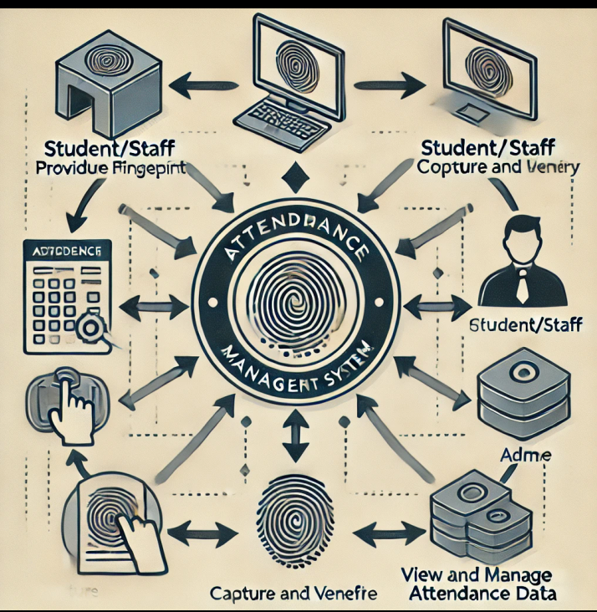

## 5.0.2 Use Case Diagram

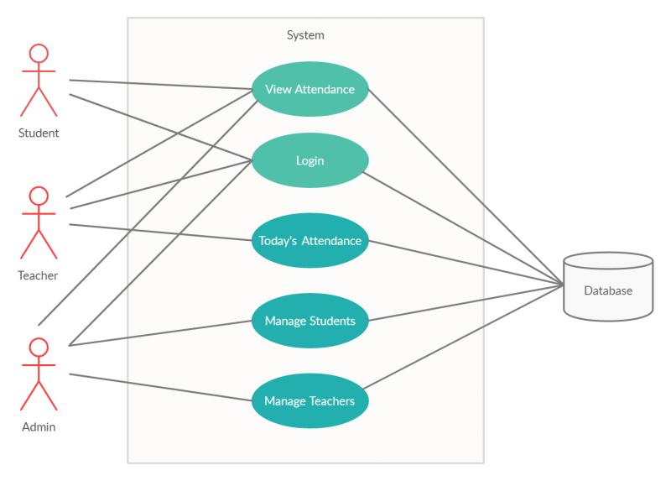

## 5.0.3 Activity Diagram

Enter course code

Fingerprint

biometrics enrollment

Matric number registered

Processing attendance

Generating reports

Match?

Database

## 5.0.4 Entity relationship diagram

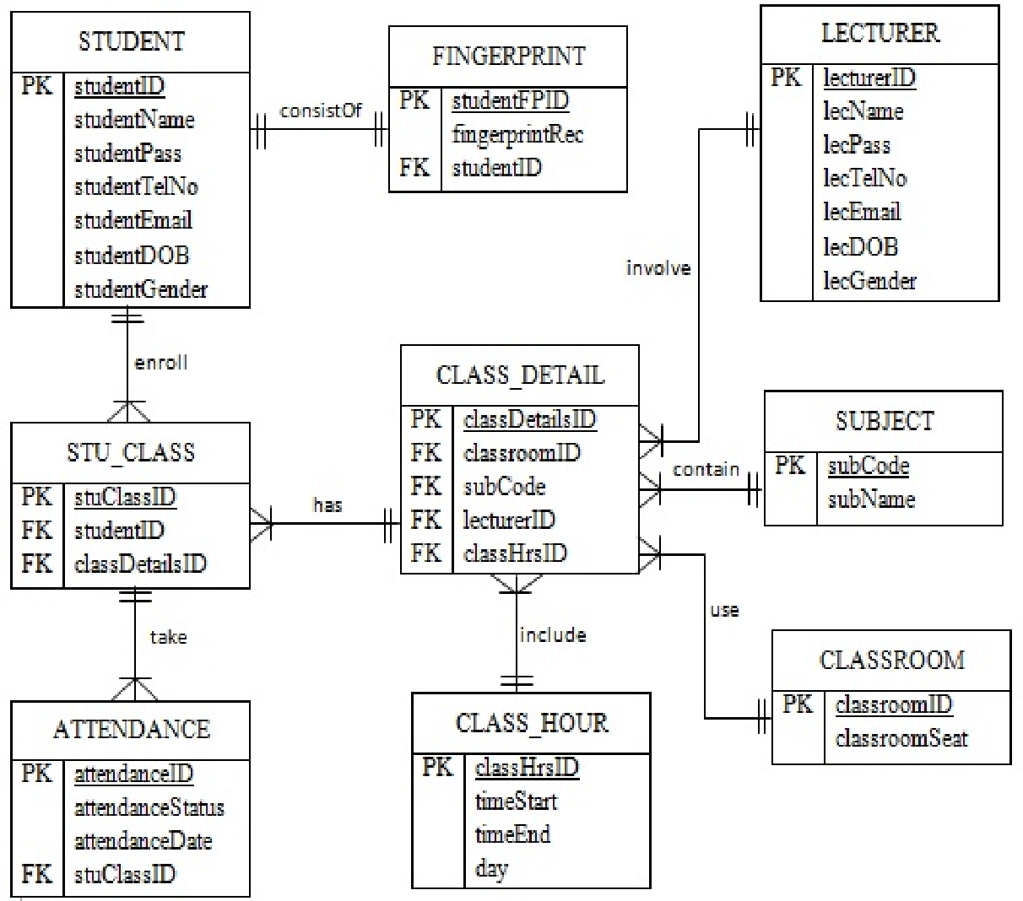

# 

# 5.1 SYSTEM REQUIREMENTS

5.1.1 Hardware Requirements  
The minimum hardware requirement in develop this system are listed as below:

|  |  |
| --- | --- |
| Hardware Description | Minimum Requirements |
| Processor | Intel Pentium D 3.4GHz / AMD Athlon II X2 250 u (Minimum) Intel Core 2 Duo E4400 2.0GHz / AMD Athlon 64 X2 Dual Core 4600+ (Recommended) |
| Memory | 1 GB RAM Recommended, 256 MB RAM (Minimum) |
| Hard disk space | Up to 3 GB Recommended |
| Display | 65536 colors, set to at least 1024 X 768 resolution |

**Table: Table of Hardware Requirements**

5.1.2 Software RequirementsThe minimum software requirement in develop this system are listed as below:

|  |  |
| --- | --- |
| Software Description | Minimum Requirements |
| Operating System (OS) | All 32-bits Microsoft Windows (95/98/2000/XP/7/8) |
| Browser | Mozilla Firefox (15.0 & above), Internet Explorer (8.0 & above), Google Chrome (20.0 & above). |

**Table: Table of Software Requirements**

After the system developed, process of system testing must be carried on in order to test if the system is free of bugs. If during the system testing, there are bugs or errors detected, the developer may need to correct and fix the bugs immediately.  
There are few types of system testing that must be performed which include the unit testing, integration testing, system testing, and acceptance testing. System testing is not a testing that limited only to the development team but it also requires the help from specific outsider (beta-tester) to test on the system acceptance.

**5.2 Validation and Testing**

### 5.2.1 Validation Methods

1. Requirement Analysis: Ensuring the system meets the functional and non-functional requirements of the educational institution.
2. System Design: Creating a detailed design of the system, including hardware and software components.
3. User Acceptance Testing (UAT): Involving end-users (students and faculty) to validate that the system meets their needs and expectations.
4. Security Testing: Ensuring the system securely handles and stores fingerprint data to protect user privacy.

### 5.2.2 Testing Methods

1. Unit Testing: Testing individual components of the system to ensure they function correctly.
2. Integration Testing: Testing the integration of different components to ensure they work together seamlessly.
3. System Testing: Testing the complete system to ensure it meets the specified requirements.
4. Performance Testing: Evaluating the system's performance under various conditions, such as high traffic and different environmental factors.
5. Usability Testing: Assessing how easy and intuitive the system is for users to interact with.
6. Regression Testing: Re-testing the system after modifications to ensure that existing functionality remains unaffected.

### 5.2.3 Criteria for evaluating the systems performance and usability

### Performance Criteria

1. Accuracy: The system's ability to correctly identify and record attendance without errors. This includes minimizing false positives (incorrectly identifying someone as present) and false negatives (failing to identify someone as present).
2. Speed: The time taken for the system to process and verify fingerprints, ensuring quick and efficient attendance recording.
3. Scalability: The system's capability to handle an increasing number of users without degradation in performance.
4. Reliability: The system's consistency in performing its functions without failures or downtime.
5. Load Handling: The system's performance under various load conditions, such as peak times when many users are trying to record attendance simultaneously.
6. Data Security: Ensuring that the system securely handles and stores fingerprint data, protecting user privacy and complying with relevant data protection regulations.

### Usability Criteria

1. Ease of Use: The system should be intuitive and easy for all users to operate without requiring extensive training or technical expertise.
2. User Interface: The design of the system's interface should be visually appealing, organized, and accessible to users of all abilities.
3. Feedback and Error Handling: The system should provide clear and helpful feedback to users, including guidance on resolving errors or issues that may arise during the attendance recording process.
4. Compatibility: The system should be compatible with various devices and platforms used by the institution, ensuring seamless integration and operation.
5. User Satisfaction: Gathering feedback from users to measure their satisfaction with the system and identify areas for improvement.

## 5.3 Ethical considerations

## 5.3.1 Privacy and Data Protection

1. Informed Consent: Users should be fully informed about the purpose of the system, the type of data being collected, and how it will be used. Obtaining explicit consent is crucial.
2. Data Minimization: Collecting only the necessary data required for the system to function, avoiding the collection of excessive or irrelevant information.
3. Data Storage and Security: Ensuring that fingerprint data is stored securely using encryption and other security measures to protect against unauthorized access or breaches.

## 5.3.2 User Rights and Autonomy

1. Right to Opt-Out: Providing users with the option to opt-out of the system and offering alternative methods of attendance recording for those who choose not to use the fingerprint system.
2. Transparency: Clearly communicating policies, procedures, and any changes related to the system to all users, maintaining transparency throughout its implementation and operation.

### 5.3.3 Bias and Fairness

1. Bias Mitigation: Ensuring that the system is designed and tested to be free from biases that could lead to unfair treatment or discrimination against certain groups of users.
2. Accessibility: Making sure the system is accessible to all users, including those with disabilities or other challenges that might affect their ability to use fingerprint technology.

### 5.3.4 Ethical Use and Oversight

1. Purpose Limitation: Using the fingerprint system solely for attendance purposes and not for other activities without the users' consent.
2. Regular Audits: Conducting regular audits and assessments to ensure the system complies with ethical standards and relevant regulations.
3. Accountability: Establishing clear accountability mechanisms to address any issues or concerns that may arise from the use of the system.

# 5.4 REFERENCES

Sogbodjor, P. (2021). Fingerprint based biometric student attendance system: A case study of Data Link Institute. GSJ Publications

Wachira, S. N. (2018). Biometrics class attendance management system. University of Nairobi.

Shoewu, O., Olaniyi, O. M., & Lawson, A. (2011). Embedded Computer-Based Lecture Attendance Management System. African Journal of Computing & ICT, 4(3), 27-36

Ivanilson, F. et al. (2012*). Developing an automatic attendance register system for CPUT.* Available at: https://www.academia.edu/4079035/Developing_an_automatic_attendance_register_system [Accessed 10 July 2014].

Subramaniam, H. et al. (2013). *Bar Code Scanner Based Student Attendance System (SAS).* Available at: http://www.researchgate.net/publication/245025631_Bar_Code_Scanner_Based_Student_Attendance_System_(SAS).

Marvia, D. (2011, June 5). *Review of Literature for Improving Attendance in Secondary Schools.* Available at: http://intuitiveedesign.wordpress.com/2011/06/05/review-of-literature-for-improving-attendance-in-secondary-schools.

Hasnieza, M. (2005). *Monitoring Attendance School through SMS.* Available at: http://library.utem.edu.my/index2.php?option=com_docman&task=doc_view&gid=3756&Itemid=113

## 5.4.1 APPENDIX 1;

**Estimated budget**

### Estimated Budget Breakdown

1. Hardware (Fingerprint Scanners): Assuming one or two scanners would be sufficient for a single class.
   * For 2 units: KES 6,500 - KES 13,000 each
   * Total: KES 13,000 - KES 26,000
2. Software: KES 13,000 - KES 26,000
3. Installation and Setup: KES 6,500 - KES 13,000
4. Maintenance and Support: KES 2,600 - KES 6,500 per year

### Total Estimated Budget in

1. Hardware: KES 13,000 - KES 26,000
2. Software: KES 13,000 - KES 26,000
3. Installation and Setup: KES 6,500 - KES 13,000
4. Maintenance and Support: KES 2,600 - KES 6,500 per year

Total: Approximately KES 35,100 - KES 71,500 for the initial setup, with an additional KES 2,600 - KES 6,500 per year for maintenance and support

## 5.4.2 APPENDIX 2;

### GANTT CHART

|  |  |  |  |  |  |  |  |  |  |  |  |  |  |  |  |  |  |  |  |  |  |  |  |  |  |  |  |  |  |  |  |  |  |  |  |
| --- | --- | --- | --- | --- | --- | --- | --- | --- | --- | --- | --- | --- | --- | --- | --- | --- | --- | --- | --- | --- | --- | --- | --- | --- | --- | --- | --- | --- | --- | --- | --- | --- | --- | --- | --- |
| |  |  |  |  | | --- | --- | --- | --- | | Task | Duration | Start date | End date | | Project initiation | 1 week | 01-Oct-24 | 07-Oct-24 | | Research and analysis | 2 weeks | 08-Oct-24 | 21-Oct-24 | | Outline proposal structure | 1 week | 22-Oct-24 | 28-Oct-24 | | Writing the proposal | 3 weeks | 29-Oct-24 | 18-Nov-24 | | Review and edit | 1 week | 19-Nov-24 | 25-Nov-24 | | Approval and sign off | 1 week | TBD | TBD | | Submission | 1 day | TBD | TBD | |  |  |  |
|  |  |  |  |
|  |  |  |  |
|  |  |  |  |
|  |  |  |  |